Exercise 1:

* URL: <https://twitter.com/home>
* IP address: [2606:2800:233:8173:898f:63b3:95c3:79d2]:443
* Number of requests : 260
* The types of requests are :
  + Document
  + Script
  + Font
  + Xhr
  + Fetch
  + Vnd.microsoft.icon
  + Manifest
  + Png
  + Jpeg
  + Svg +xml
  + Eventsource
  + Ping
* The largest file requested : 370 Kb
* It took 220 ms to load

Exercise 2 :

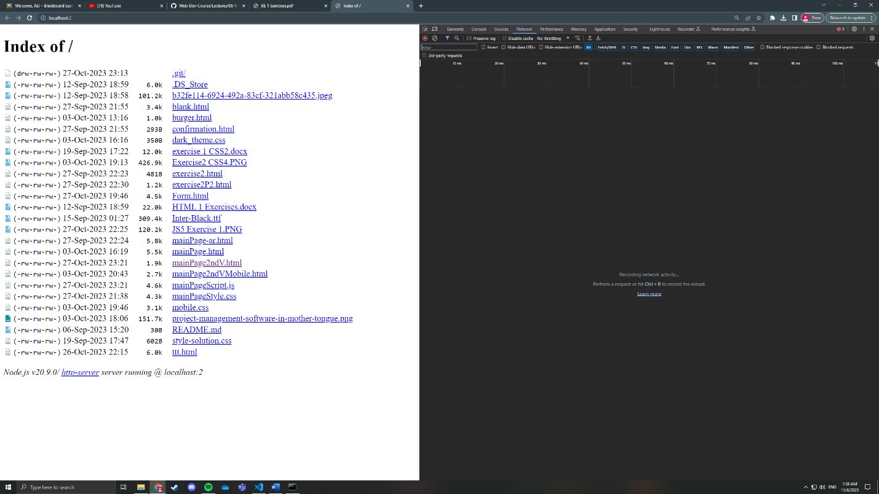

Exercise 3 :

alisjourneythroughswe363.com